Project Report
Implement Client Script & UI Policy (Incident)
ServiceNow Incident Management
Team ID: SWTID-2026-1916
Date: 08 October 2026
Team ID : SWTID-2026-1916
Team Size : 5
Team Leader : JANANI M
Team member : KANISHKA P
Team member : KARTHIKA M
Team member : KAVIYA S
Team member : LOGESWARI V
link:https://github.com/karthikakarthika06/implement-client-script-and-ui-policy.git

1. INTRODUCTION

1.1 Project Overview
This project shows how ServiceNow client-side controls enforce data integrity on Incident records. A UI Policy and three Client Scripts (onChange, onSubmit, onCellEdit) control field behavior, auto-populate values and block invalid saves, so Incidents are submitted with complete and valid information.

1.2 Purpose
Relying on user awareness alone leads to incomplete or inconsistent Incident data, which hurts triage, routing, reporting accuracy and SLA compliance. The purpose of this project is to enforce business rules at the user-interface level:
- Make fields mandatory or read-only conditionally when Impact is High.
- Automatically set Urgency for High impact incidents.
- Prevent saving a High impact incident without an assignee.
- Prevent direct State changes from the list view.

2. IDEATION PHASE

2.1 Problem Statement
Incident records require consistent and accurate data entry for effective triage, routing and resolution. Manual checks lead to incomplete, inconsistent or incorrect data, affecting reporting accuracy, SLA compliance and service quality. There is a need to enforce conditional field behavior and validation directly on the Incident form.

2.2 Empathy Map Canvas
Draft based on the problem statement; edit to reflect your team's own empathy map.
Quadrant | Service desk agent / incident manager
Says | "This ticket is missing an assignee." "Why is the priority wrong?"
Thinks | Bad data delays routing and puts SLAs at risk.
Does | Chases callers and teammates to fix incomplete tickets; re-opens records to correct fields.
Feels | Frustrated by rework; worried about missed SLAs.
Pains | Inconsistent urgency/priority, unassigned high impact incidents, accidental state changes from lists.
Gains | Clean, complete records; faster triage; reliable reports.

2.3 Brainstorming
Draft options considered; edit to reflect your team's session.
- Training and manual checks only - Rejected: relies on user awareness and does not scale.
- Business Rules (server-side) - Possible, but feedback comes only after submit.
- UI Policy + Client Scripts (selected) - Immediate feedback on the form, no server round-trip, easy to configure.

3. REQUIREMENT ANALYSIS

3.1 Customer Journey Map
Stage | Create Incident | Set Impact = High | Save | Update / list view
User action | Opens new Incident form | Selects 1 - High | Clicks Submit | Edits State, lowers Impact
System response | Form loads with UI Policy active | Assignment group mandatory, Urgency set to High and locked | Blocked if Assigned to is empty | List edit blocked; policy reverses when Impact is not High
Experience | Clear form | Guided by the form | Immediate error message | Consistent, predictable behavior

3.2 Solution Requirement
Functional requirements
- FR-1: When Impact = 1 - High, Assignment group must be mandatory.
- FR-2: When Impact = 1 - High, Urgency must be read-only.
- FR-3: Changing Impact to High must set Urgency to 1 - High and show an info message.
- FR-4: A High impact Incident cannot be saved without Assigned to; an error is shown on the field.
- FR-5: State cannot be changed by editing a list cell; an alert is displayed.
- FR-6: When the condition is no longer true, UI Policy effects are reversed.
Non-functional requirements
- Client-side only, lightweight, no server round-trip for validation.
- Configured with standard ServiceNow features; no custom tables.
- Works on the Incident table in the Global application scope.

3.3 Data Flow Diagram
User edits Incident form / list
▼
Client-side controls evaluate (UI Policy, Client Scripts)
▼
Valid? Yes: record is saved
▼
Incident table (incident)
If a rule fails (for example High impact with empty Assigned to, or a list edit of State), the client script cancels the action and displays a message; nothing is sent to the Incident table.

3.4 Technology Stack
Component | Technology
Platform | ServiceNow (developer instance)
Table | Incident [incident]
Declarative controls | System UI > UI Policies and UI Policy Actions
Scripting | Client Scripts in JavaScript (GlideForm g_form API): onChange, onSubmit, onCellEdit
Scope | Global

4. PROJECT DESIGN

4.1 Problem Solution Fit
Problem: incomplete or inconsistent Incident data. Fit: rules run on the form at the moment of entry, so users correct problems immediately instead of after the fact. The combination of declarative UI Policy and targeted Client Scripts covers mandatory/read-only behavior, auto-population and save/list validation.

4.2 Proposed Solution
Component | Behavior
UI Policy "High Impact Control" | Condition Impact is 1 - High; Reverse if false = true.
UI Policy Action: Assignment group | Mandatory = True, Read only = False.
UI Policy Action: Urgency | Read only = True, Visible = Leave alone.
onChange: Auto set urgency for high impact | On Impact change to 1, sets Urgency to 1 and shows an info message.
onSubmit: Prevent save if Assigned To missing | If Impact is 1 and Assigned to is empty, shows an error and cancels the save.
onCellEdit: Prevent state change via list edit | Alerts the user and cancels State edits made in the list.

4.3 Solution Architecture
Incident form / list (browser)
▼
UI Policy engine + Client Scripts (g_form)
▼
Incident table on the ServiceNow instance

5. PROJECT PLANNING & SCHEDULING

5.1 Project Planning
Task | Activity | Status | Dates
Task 1 | Create UI Policy "High Impact Control" (Assignment group mandatory) | Completed | [add]
Task 2 | Create UI Policy Action for Urgency (read-only) | Completed | [add]
Task 3 | Create onChange Client Script | Completed | [add]
Task 4 | Create onSubmit Client Script (save validation) | Completed | [add]
Task 5 | Create onCellEdit Client Script | Completed | [add]
Task 6 | Testing the configuration (5 activities) | Completed | [add]

6. FUNCTIONAL AND PERFORMANCE TESTING

6.1 Performance Testing
Eight functional test cases were run (see the UAT document, Team ID SWTID-2026-1916). All eight passed, a 100% pass rate.
ID | Scenario | Result | Type
TC-001 | High impact: Assignment group mandatory, Urgency read-only | Pass | Positive
TC-002 | onChange sets Urgency to High | Pass | Positive
TC-003 | Save blocked without Assigned to | Pass | Negative
TC-004 | Save succeeds with Assigned to | Pass | Positive
TC-005 | Reverse condition (High to Medium) | Pass | Positive
TC-006 | State list edit blocked | Pass | Negative
TC-007 | State update via form allowed | Pass | Positive
TC-008 | Other fields still follow rules | Pass | Positive

7. RESULTS

7.1 Output Screenshots
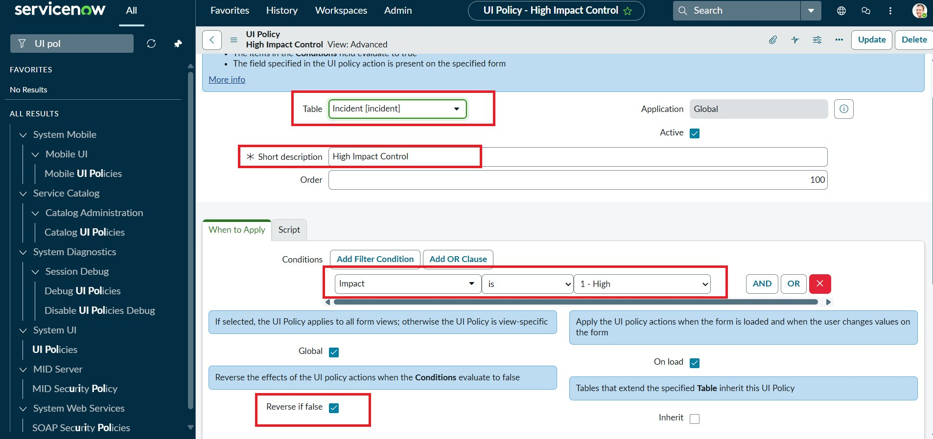
Figure 1: UI Policy "High Impact Control" with Impact = 1 - High and Reverse if false
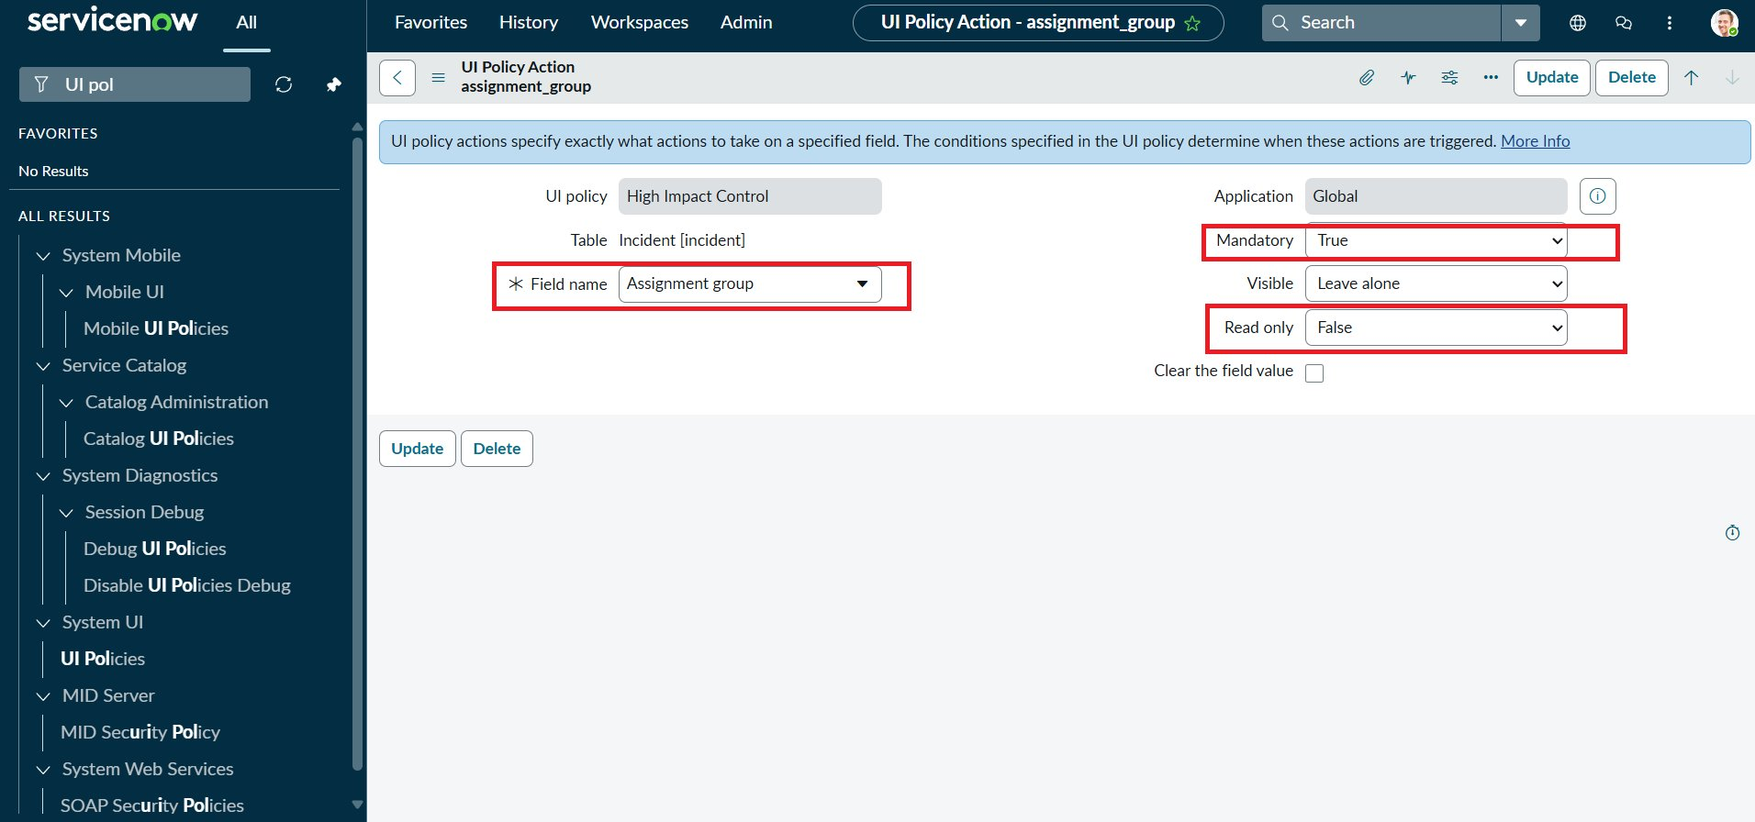
Figure 2: UI Policy Action - Assignment group mandatory
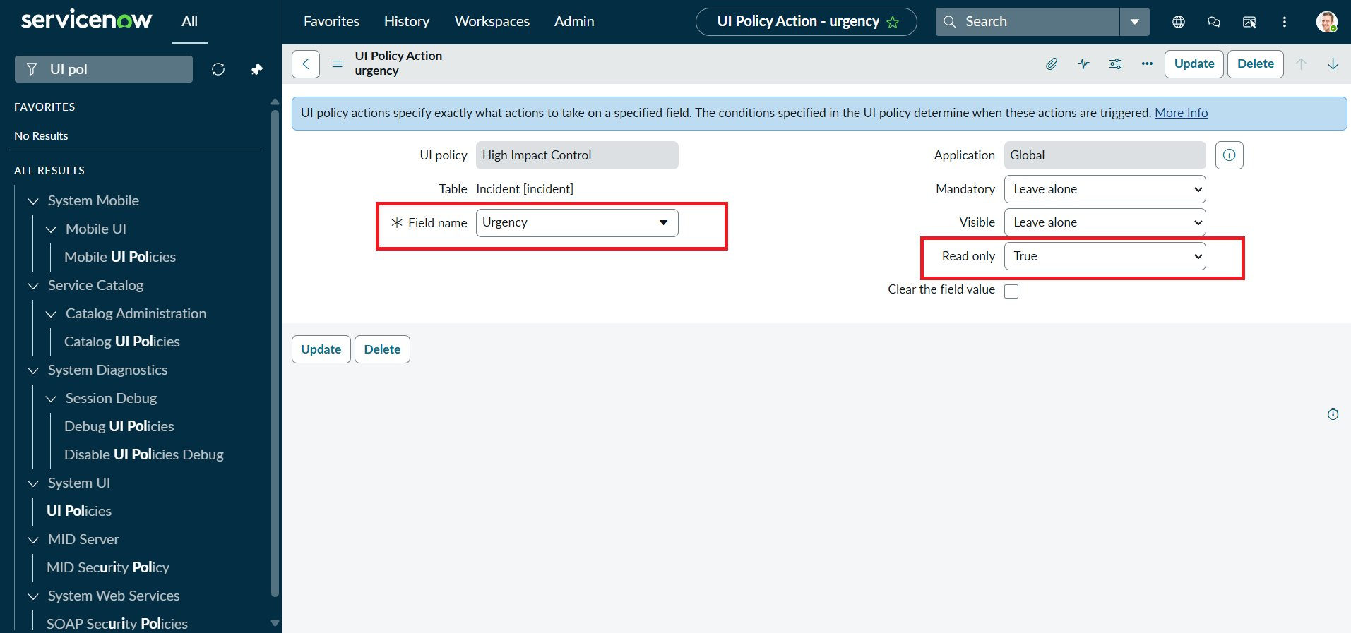
Figure 3: UI Policy Action - Urgency read-only
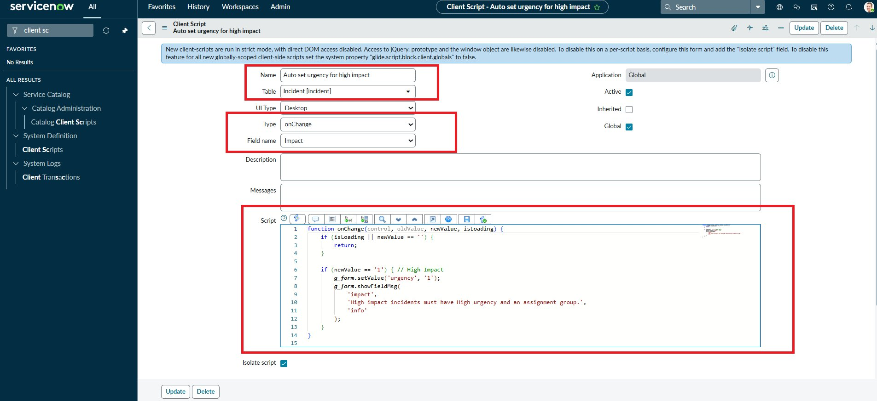
Figure 4: onChange Client Script
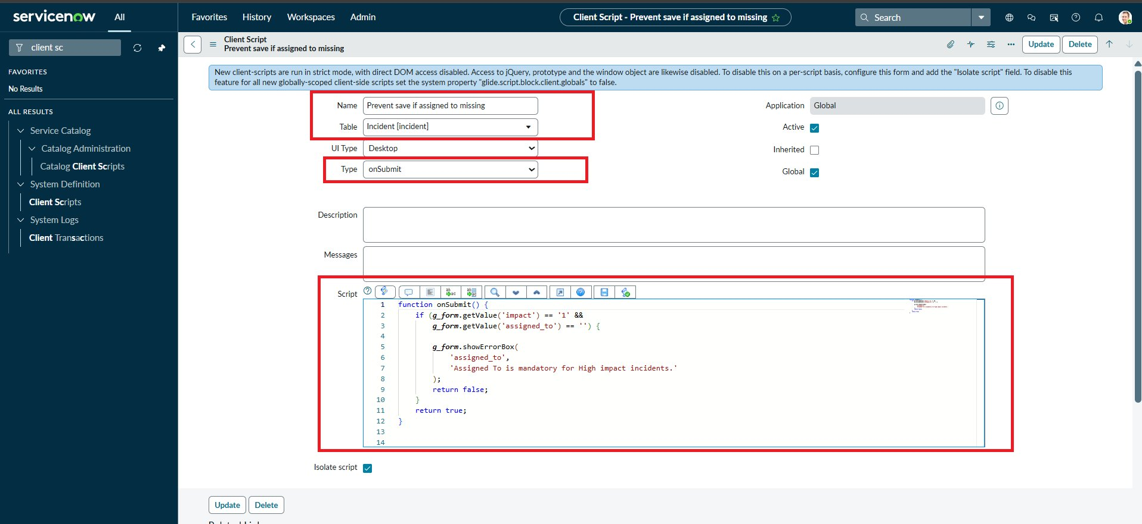
Figure 5: onSubmit Client Script
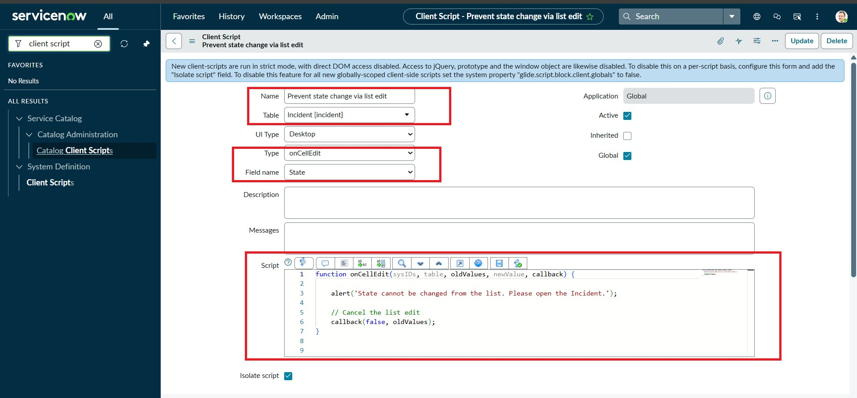
Figure 6: onCellEdit Client Script
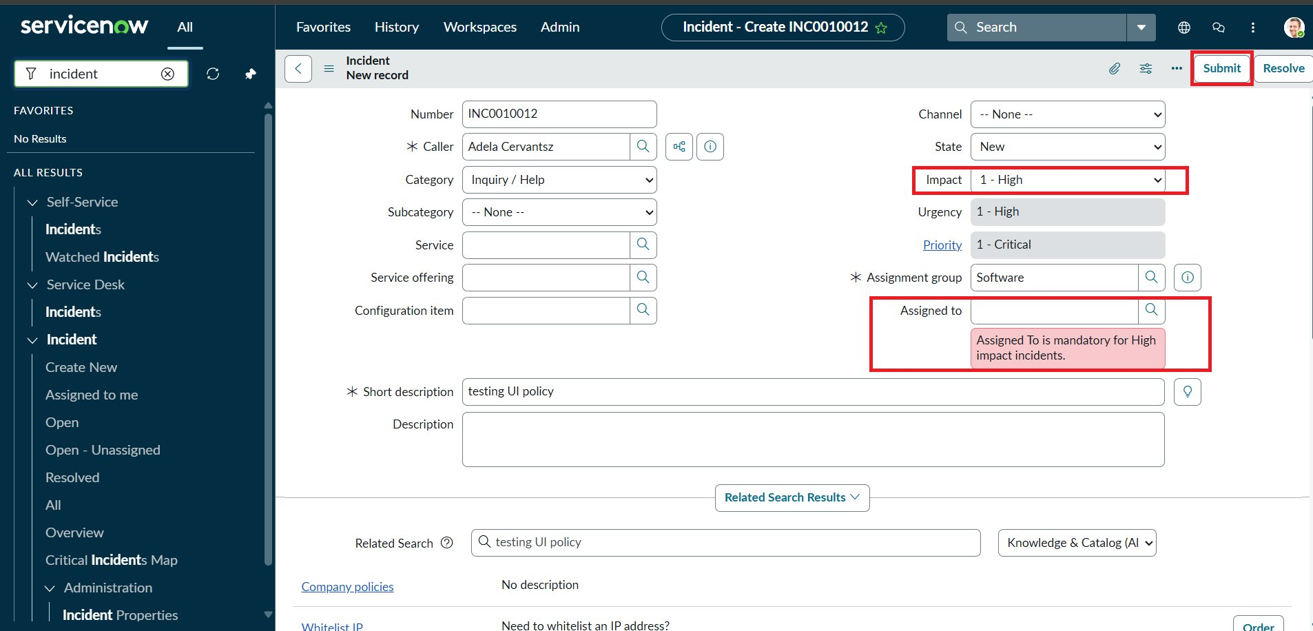
Figure 7: Save blocked - Assigned To is mandatory for High impact incidents
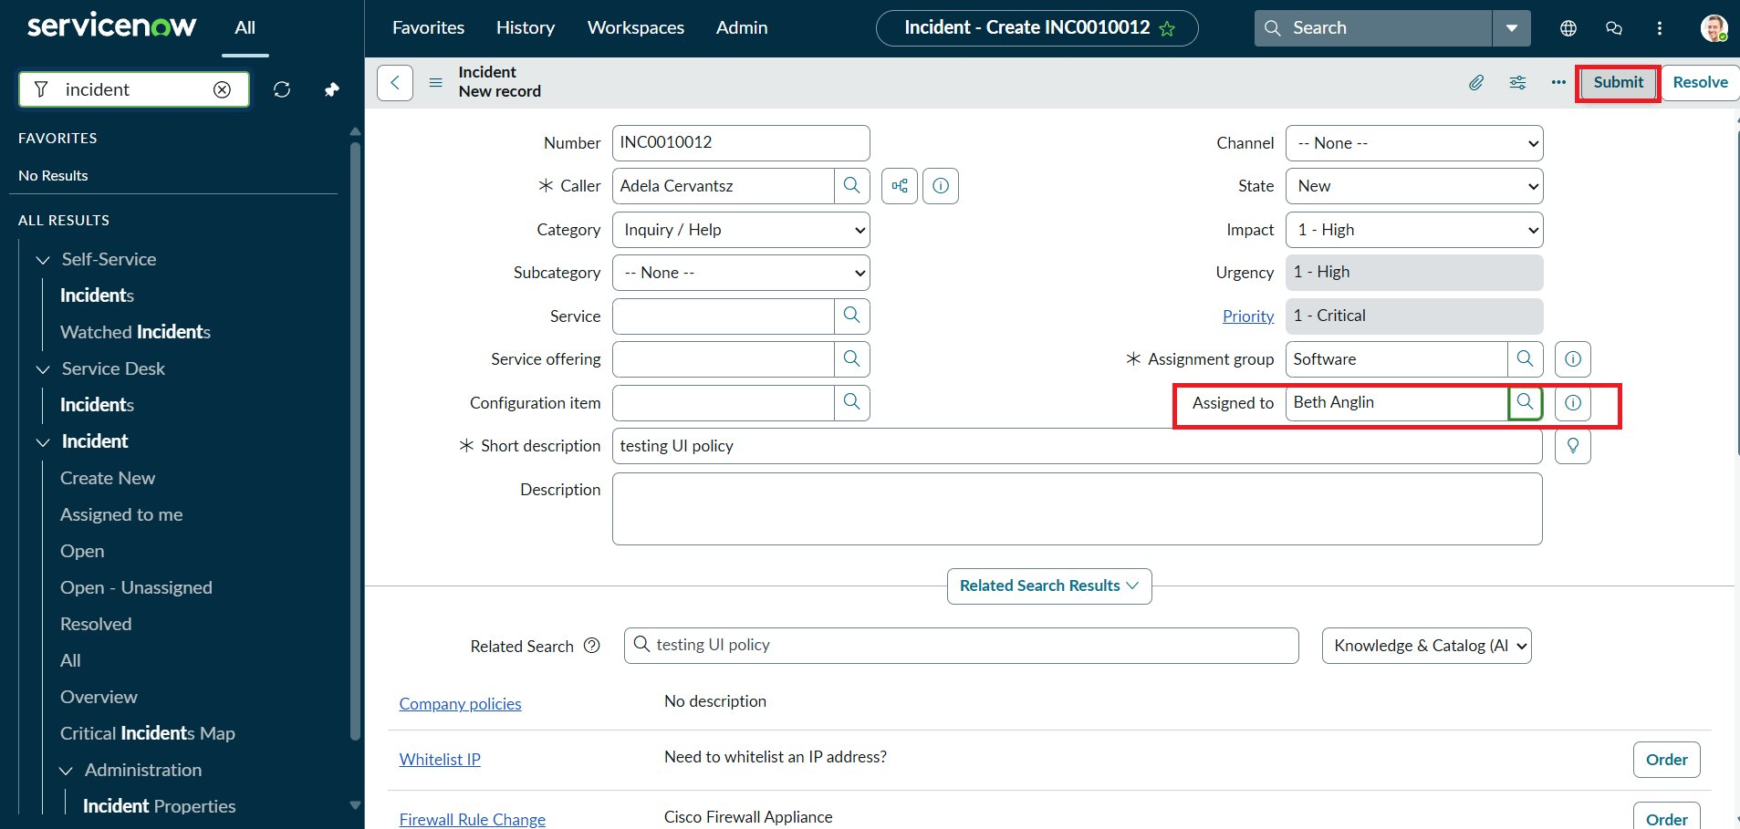
Figure 8: Successful save with Assigned to filled
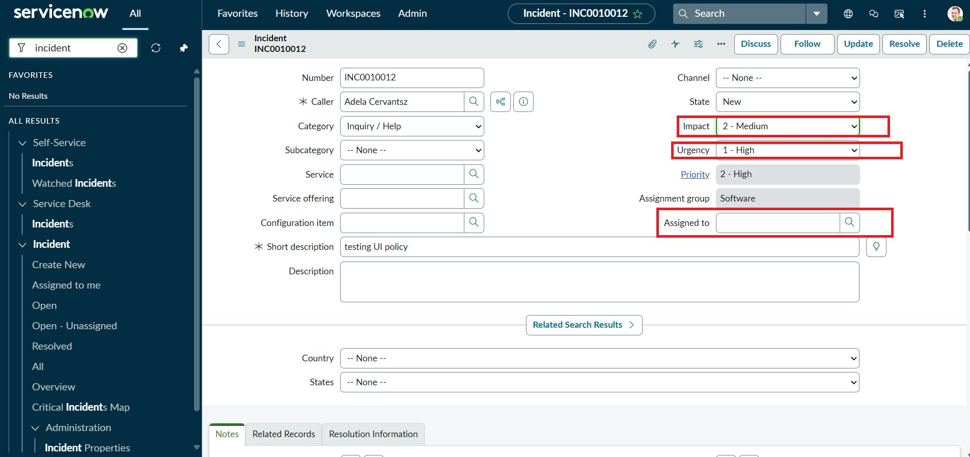
Figure 9: Reverse condition - Impact changed to Medium
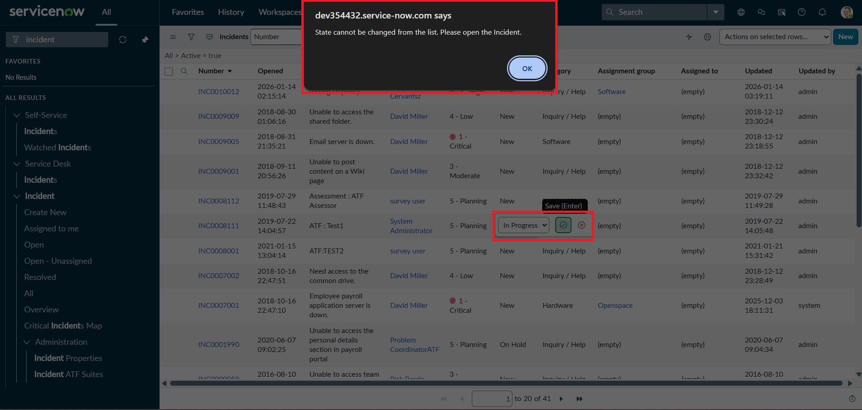
Figure 10: List edit of State blocked with alert
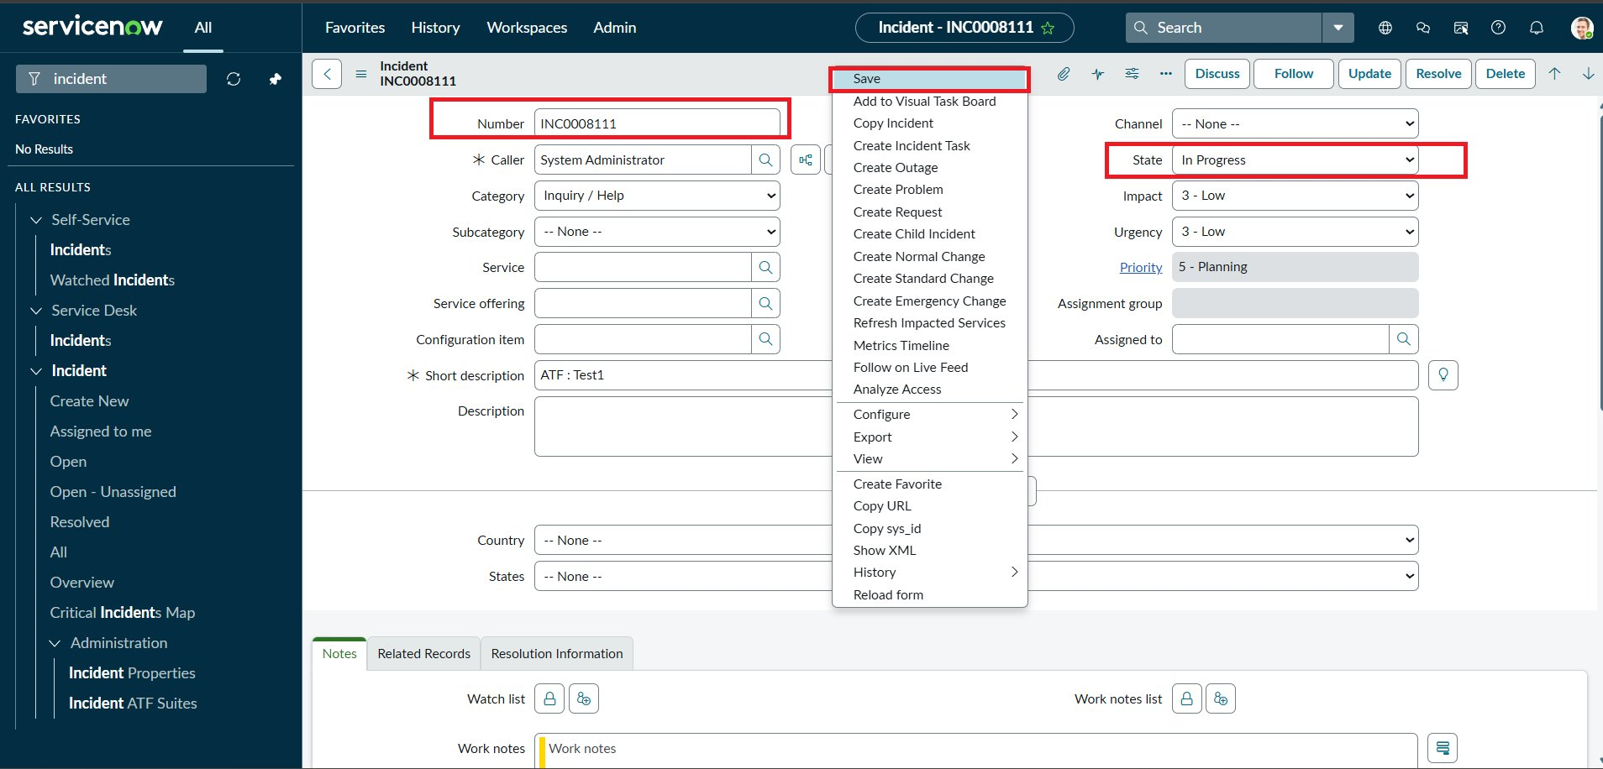
Figure 11: State updated from the Incident form
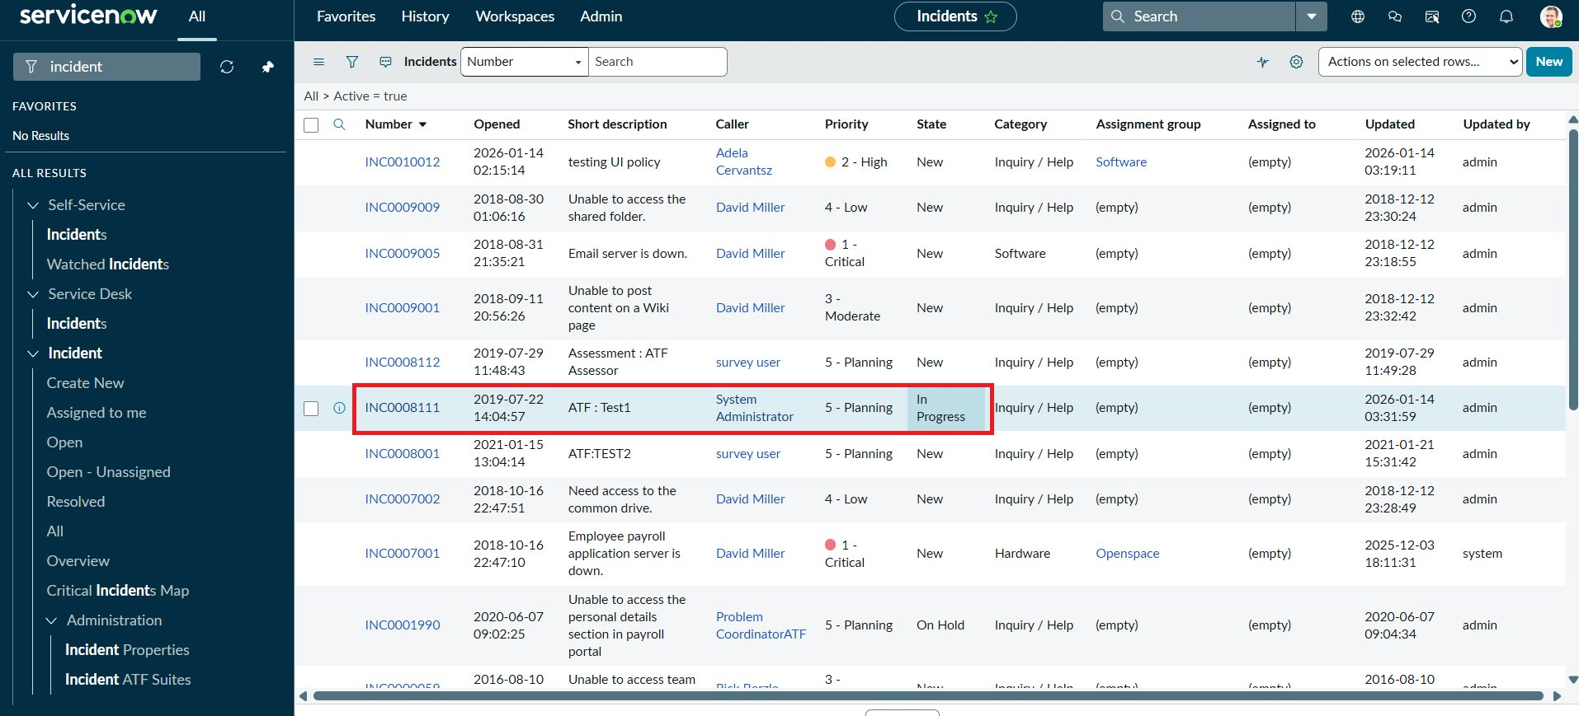
Figure 12: Updated State shown in the list

8. ADVANTAGES & DISADVANTAGES
Advantages
- Improves data quality and consistency across Incident records.
- Immediate feedback to users on the form.
- Lightweight and easy to implement with standard platform features.
- UI Policy reverses automatically when the condition no longer applies.
Disadvantages
- Client-side rules can be bypassed by imports, integrations, APIs or other non-form updates; server-side Business Rules or Data Policies are needed for full enforcement.
- The onChange script sets Urgency but does not reset it when Impact is lowered.
- Scripts must be maintained if field names or business rules change.

9. CONCLUSION
The project shows that UI Policies and Client Scripts work together to enforce dynamic field behavior, automate updates and prevent incorrect data submission on Incident forms. All test cases passed, and the solution is lightweight, effective and easy to apply.

10. FUTURE SCOPE
- Add server-side Data Policies or Business Rules so the same rules apply to imports and APIs.
- Reset or recalculate Urgency when Impact is lowered.
- Extend rules to Priority, Category and Resolution notes on resolve/close.
- Add rules for Problem and Change tables and role-based exceptions.
- Add automated tests using the Automated Test Framework.

11. APPENDIX

Source Code
Client Script: Auto set urgency for high impact (onChange, field: Impact)
function onChange(control, oldValue, newValue, isLoading) {
if (isLoading || newValue == '') {
return;
}
if (newValue == '1') {
g_form.setValue('urgency', '1');
g_form.addInfoMessage('Urgency set to High for High impact incident.');
}
}

Client Script: Prevent save if Assigned To missing (onSubmit)
function onSubmit() {
if (g_form.getValue('impact') == '1' &&
g_form.getValue('assigned_to') == '') {
g_form.showErrorBox(
'assigned_to',
'Assigned To is mandatory for High impact incidents.'
);
return false;
}
return true;
}

Client Script: Prevent state change via list edit (onCellEdit, field: State)
function onCellEdit(sysIDs, table, oldValues, newValue, callback) {
alert('State cannot be updated using list editing. Please open the Incident.');
callback(false);
}

Dataset Link
Not applicable (no external dataset; uses the Incident table of the ServiceNow instance).

GitHub & Project Demo Link
GitHub: https://github.com/karthikakarthika06/implement-client-script-and-ui-policy.git
Demo video: [add link]

